**DAILY ONLINE ACTIVITIES SUMMARY**

|  |  |  |  |  |  |  |  |
| --- | --- | --- | --- | --- | --- | --- | --- |
| **Date:** | **16-06-2020** | | | | **Name:** | **Jaidithya** | |
| **Sem & Sec** | **6 B** | | | | **USN:** | **4AL17CS118** | |
| Online Test Summary | | | | | | | |
| **Subject** | | **Python workshop test** | | | | | |
| **Max. Marks** | | **20** | | **Score** | | **11** | |
| Certification Course Summary | | | | | | | |
| **Course** | **Python workshop exercises** | | | | | | |
| **Certificate Provider** | | |  | **Duration** | | | **5 DAYS** |
| Coding Challenges | | | | | | | |
| **Problem Statement-one python program and workshop programs** | | | | | | | |
| **Status:Executed** | | | | | | | |
| **Uploaded the report in Github in slack** | | | | **Yes** | | | |
| **If yes Repository name** | | | | **16th june** | | | |
| **Uploaded the report in github workshop python link** | | | | **https://github.com/jaidithya/ Workshop.git** | | | |

Online Test Details: (Attach the snapshot and briefly write the report for the same)

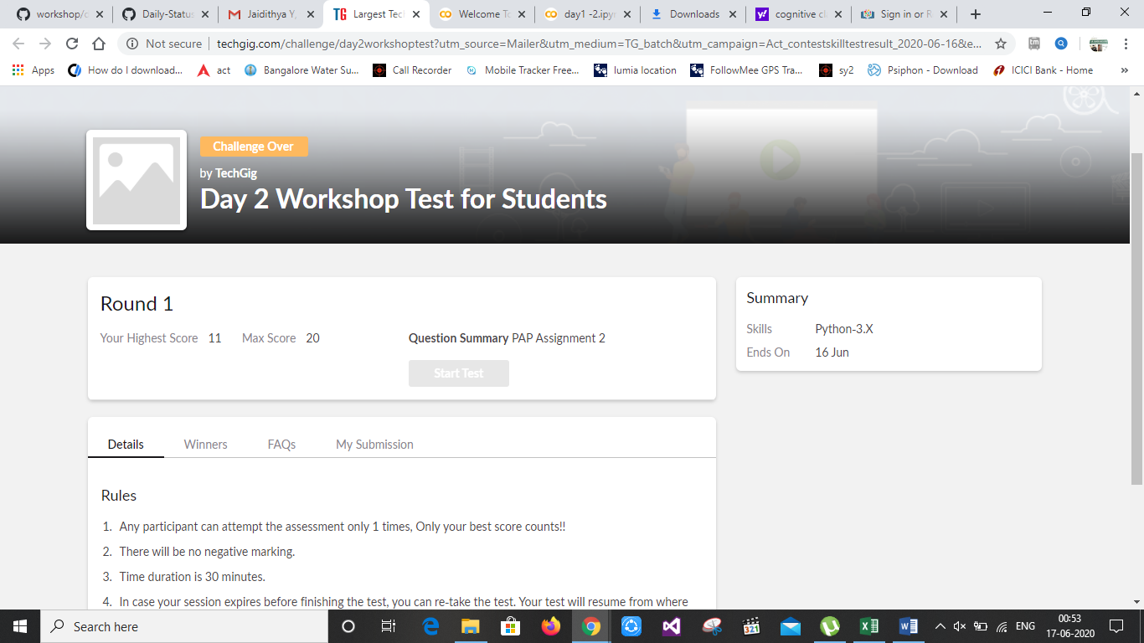

Certification Course Details: (Attach the snapshot and briefly write the report for the same)

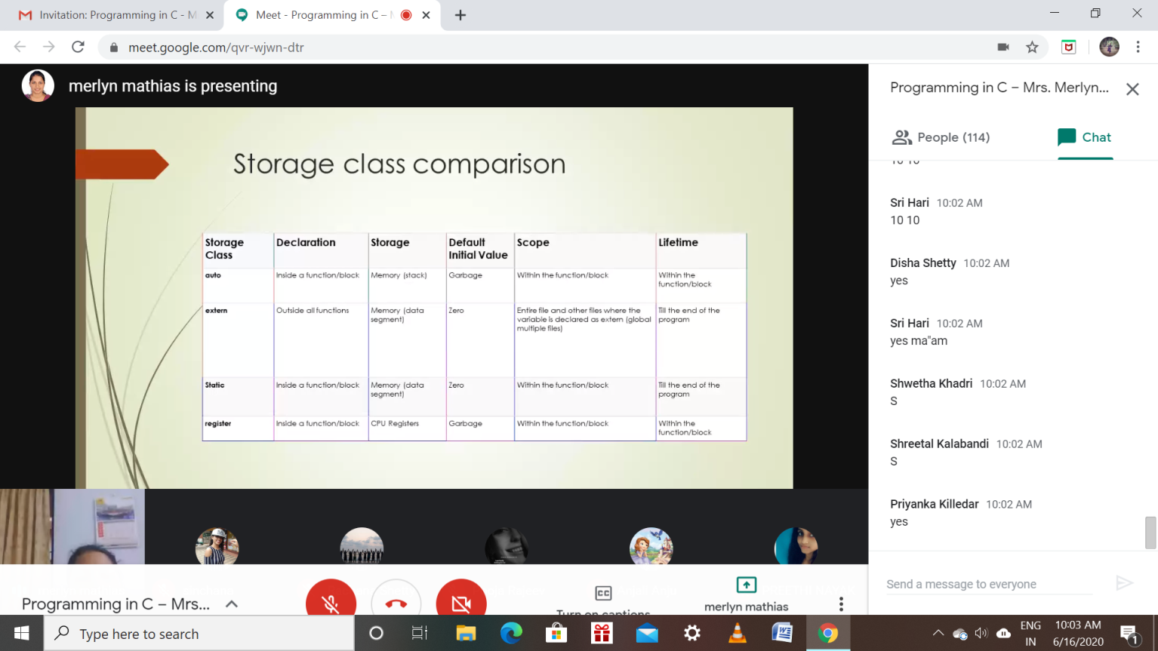

Coding Challenges Details: (Attach the snapshot and briefly write the report for the same)

Program1:

